Predictive Modeling of EV Charging Congestion
Geospatial Supply-Demand Gap Analysis


MPBA G513 — Predictive Analytics

SUBMITTED
TO
Prof. Abhishek Verma

SUBMITTED BY GROUP 10
Name | BITS ID
A Atul | 2025H1540842P
Ayushi Aggarwal | 2025H1540820P
Avatansh Pandey | 2025H1540809P
Jayasuriya P | 2025H1540850P

BIRLA INSTITUTE OF TECHNOLOGY AND SCIENCE PILANI, PILANI CAMPUS
Table Contents
Chapter 1: Introduction & Case Study Context
1.1 Motive for the project
1.2 The Emerging Challenge
1.3 Overview of the Study
Chapter 2: Literature Review
2.1 ML for EV Charging Demand Forecasting
2.2 Geospatial Optimisation for Charger Placement
2.3 Supply-Demand Gap Analysis in EV Infrastructure
2.4 Indian EV Ecosystem and Policy Context
2.5 Research Gap and Positioning
Chapter 3: Problem Statement, Objectives & Scope
3.1 Statement of the Problem
3.2 Originality
3.3 Objectives
Chapter 4: Methodology & Model Development
4.1 Data Sources & Collection Strategy
4.2 Statistical Preprocessing & Verification
4.3 Phase 1 — DBSCAN Geospatial Clustering
4.4 Phase 2 — Congestion Index (CI) & CaaS Deployment Score (CDS)
4.5 Phase 3 — Prophet Time Series Forecasting
4.6 Phase 4 — XGBoost Zone Ranking
4.7 Characteristic Features of the Methodology
Chapter 5: Results & Analysis
5.1 Exploratory Data Analysis
5.2 Clustering Results & Charging Desert Identification
5.3 Congestion Index Distribution & Zone Rankings
5.4 Predictive Model Performance
Chapter 6: Discussion & Managerial Implications
6.1 Key Findings
6.2 Managerial Implications for CPOs
6.3 Policy Implications
Chapter 7: Conclusions, Limitations & Future Scope
7.1 Contributions
7.2 Limitations
7.3 Scope for Future Research
References

Chapter 1: Introduction & Case Study Context

1.1 Motive for the project
This project began with a simple but powerful observation — India's EV adoption story is no longer about whether people will buy electric vehicles. That question has been answered. Over 1.3 million EVs are registered today, the government has committed 11,500 crore under FAME-II, and PM E-DRIVE launched in October 2024 to accelerate the next wave. The real question — the one nobody has a clean data-driven answer to yet — is: where should the chargers go?
India has 29,000 public EV charging stations against approximately 6.8 million registered EVs — a charger-to-EV ratio of roughly 1:235. The government target is 1.3 million charging stations by 2030. That is a 45x scale-up in under five years. But the problem isn't just quantity. It's placement intelligence. Charging station deployment in India today is driven by three flawed logics: land availability, operator preference, and government mandate. None of these are demand-driven. The consequence is a split failure — overcrowding in the right places and underutilization in the wrong ones
1.2 The Emerging Challenge
The failure is not one of quantity but of placement logic. Current deployment decisions rely on land availability and operator relationships rather than demand data. The result is a tri-fold failure: 25–45 minute wait times at correctly-intuited commercial hotspots; 8–12% utilisation rates at misplaced residential-zone chargers (28-month payback); and complete charging deserts in peri-urban corridors growing above 100% YoY in EV registrations. The information gap common to all three failures is the absence of zone-level demand forecasting and placement intelligence.
1.3 Overview of the Study
This project develops the EV Charging Demand Intelligence Platform — a predictive decision-support system using open-source data, spatial clustering, and ensemble machine learning to rank micro-zones for fast-charger deployment across the Bengaluru metropolitan area (40 zones, 1 km × 1 km grid). The platform's design reflects a key market insight: CPOs such as Bolt.Earth (56% private market share, 100,000+ deployed chargers) make ₹15–20 lakh CAPEX commitments locked for five or more years, while CaaS operators such as Teslavolts (GIFT City, Gujarat) deploy mobile PowerPod/PowerVault units at ₹15,000 per move, revocable in 24 hours. Both actors need different outputs from the same underlying data — the dual Congestion Index (CI) and CaaS Deployment Score (CDS) architecture directly serves this split.

Chapter 2: Literature Review
This chapter synthesises research published between 2018 and 2026 across five thematic areas. The review establishes theoretical foundations, identifies methodological precedents, and positions this project's contributions against the existing body of work.
2.1 Machine Learning for EV Charging Demand Forecasting
Hussain and Eswarakrishnan (2025) proposed a hybrid LSTM-Transformer model for 30–240 day charging demand prediction, achieving 16–17% lower MAE than standalone LSTM at the 30-day horizon. Mao et al. (2026) built a stacked ensemble combining Random Forest, GBDT, LightGBM, and BiLSTM across four Chinese cities, reporting 6–20% MAE improvement over single-model baselines. Their SHAP analysis identified charger power rating and pricing as dominant demand predictors — consistent with this project's 3× fast-charger weighting in the CI denominator. Orzechowski et al. (2023) achieved SMAPE ≈ 5.9% on a multi-station UK medium-term forecasting framework using deep learning on three years of data. Zhang et al. (2025), applying XGBoost and CatBoost to California charging data, found that a 30% increase in renewable energy share correlated with a 47% rise in charging demand — illustrating the policy-sensitivity of demand forecasts that motivates this project's Prophet changepoint treatment.
2.2 Geospatial Optimisation for Charger Placement
Roy et al. (2025) demonstrated a 15–22% higher utility score over existing placements using a GIS-MCDM-metaheuristic approach in Bhubaneswar, India, confirming that systematic optimisation outperforms intuitive siting. Abdullahi et al. (2024) augmented K-Means with EV-specific penalty terms to prevent clustering in low-demand zones — a methodological limitation that this project resolves by replacing K-Means with DBSCAN, which discovers irregularly shaped clusters without a pre-specified cluster count. Prakobkaew and Sirisumrannukul (2024) used a mixed-integer covering location model with GIS grid partitioning at national scale in Thailand, validating that grid-based spatial frameworks produce replicable, scalable placement intelligence.
2.3 Supply-Demand Gap Analysis in EV Infrastructure
Li et al. (2024) used a CNN-LSTM hybrid to project China's EV-to-charger ratio to approximately 10.2:1 by 2025, demonstrating that dynamic gap analysis — incorporating growth forecasting rather than static snapshots — is necessary for investment planning. Jha et al. (2025) applied the Enhanced Two-Step Floating Catchment Area (E2SFCA) method to Delhi's charging network, estimating 105 urban and 150 peri-urban additional stations for 93% coverage. This project's Congestion Index extends such analyses by incorporating temporal growth dynamics and grid stability into the supply-demand ratio, producing a richer signal than area-coverage metrics provide.

2.4 Indian EV Ecosystem and Policy Context
Khan et al. (2025) confirmed charger availability as a top adoption barrier from both manufacturer and consumer perspectives. Rajmal and Gupta (2025) established a statistically significant positive correlation between public charger density and EV adoption rates across Indian states using panel data — econometric evidence that infrastructure investment directly drives demand growth. India's policy architecture has evolved from FAME-II (₹11,500 crore, 2019–2024) to PM E-DRIVE (₹10,900 crore, 2024–2028), which allocates ₹2,000 crore specifically for 72,300 public fast-charging points (Ministry of Heavy Industries, 2024). Despite this ambition, only 9.6% of required infrastructure funding has been mobilised (India EV Digest, 2023), highlighting a capital gap that ROI-focused placement tools can help bridge by improving CPO investor confidence.

2.5 Research Gap and Positioning
The reviewed literature demonstrates robust individual advances in ML forecasting, geospatial optimisation, gap analysis, and Indian market studies. No existing work integrates all four dimensions — demand prediction, spatial clustering, congestion quantification, and financial viability assessment — into a unified framework calibrated for Indian commercial micro-zones. Further, most geospatial studies operate at city or district granularity; CPO investment decisions require 1–2 km micro-zone intelligence. The dual-output CAPEX/OPEX architecture and the explicit treatment of FAME-II and PM E-DRIVE as Prophet changepoints are absent from the existing literature. This project addresses all three gaps.

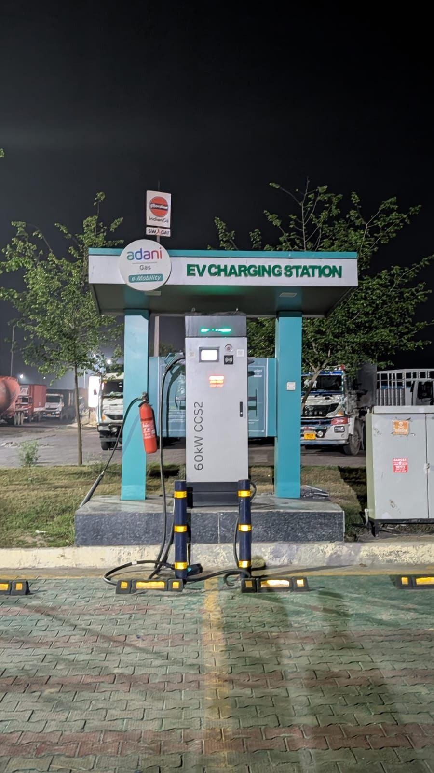

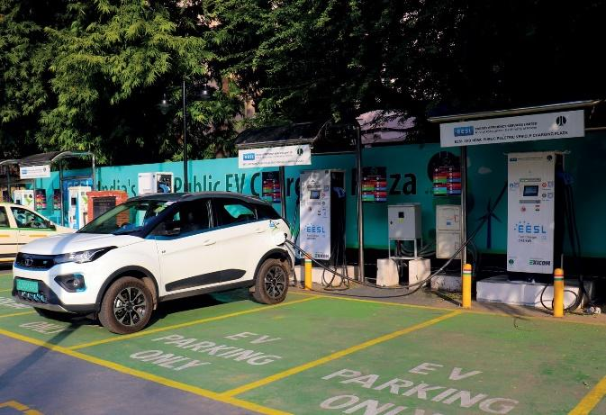

Chapter 3: Problem Statement, Objective & Scope
3.1 Statement of the Problem
EV charger placement in Indian cities is reactive — driven by land availability and mandate rather than demand evidence. The result is three simultaneous failures: overcrowded hotspots (25–45 min wait times), misplaced installations (8–12% utilisation, 28-month payback), and complete charging deserts in high-growth corridors. Each misplaced DC fast-charger represents ₹15–25 lakhs in stranded CAPEX. The research question: can a public-data pipeline reliably rank micro-zones by unmet charging demand and produce calibrated, dual-horizon decision outputs for CPO investment and CaaS routing simultaneously?
3.2 Originality
Three contributions distinguish this work: (i) a dual-output pipeline (CI for CAPEX, CDS for OPEX) from one data architecture — no compromise serving both; (ii) repurposing DBSCAN noise-point zones as CaaS first-mover targets rather than discarding them; and (iii) FAME-II and PM E-DRIVE as explicit Prophet changepoints — treating policy events as structural demand signals, not noise.
3.3 Objectives
Primary:
- Build a seven-module pipeline integrating EV registration, charger supply, POI, footfall, and land cost into a unified 1 km × 1 km zone dataset for Bengaluru.
- Identify demand clusters and charging deserts via DBSCAN; elevate noise-point zones to CaaS priority.
- Compute CI (CAPEX signal) and CDS (OPEX routing signal) per zone.
- Forecast 12-month zone-level EV growth via Prophet with changepoints; rank zones via XGBoost.
Secondary:
- Validate pipeline via VIF, PCA, and Moran's I before modelling.
- Compute unit economics (payback, daily revenue, ROI tier) using Teslavolts CPO Calculator benchmarks.
- Derive managerial and policy recommendations for CPOs and government subsidy allocators.

Chapter 4: Methodology & Model Development
The pipeline runs in four sequential phases — Cluster → Score → Forecast → Rank — preceded by a seven-module data acquisition and verification stage. Each phase feeds the next; any module can be updated independently.

4.1 Data Sources & Pipeline

Module | Source | Method | Key Variables | Pipeline Role
M1 — EV Demand | Vahan / MoRTH | Selenium automation | EV count; YoY growth rate per RTO zone | CI numerator — demand signal
M2 — Charger Supply | EV Yatra, eHUB-MG | API / scraping | Slow AC (7 kW) count; DC fast (50 kW+) count | CI denominator — supply signal
M3 — POI Grid | OpenStreetMap Overpass | Overpass API | poi_score (dwell × EV ownership likelihood) | Commercial demand potential
M4 — Footfall | Google Popular Times; Zomato | Scraping / API | footfall_composite (0–100 peak busyness) | CDS numerator; peak demand
M5 — Land & Future Supply | MagicBricks; RERA Karnataka | Web scraping | Property price; upcoming construction pipeline | CAPEX risk; forward demand
M6 — Compiler | GeoPandas spatial join | Python geospatial | Unified 1 km grid — all features aligned | Cross-source alignment
M7 — Verification | Statistical tests | VIF, PCA, Moran's I | VIF scores; PCA components; spatial correlation | Pre-modelling quality check
Table 4.1: Seven-Module Data Pipeline
Key design decisions: M1 uses Selenium because Vahan has no public API. M2 weights DC fast chargers 3× slow chargers (throughput-adjusted: one 50 kW unit ≈ 3–4 vehicles per session window of a 7 kW unit). M3 scores POIs on dwell time and EV ownership likelihood (IT parks: 10/10; hotels: 9; malls: 8; restaurants: 5; pharmacies: 1). M5 dual function — MagicBricks provides current CAPEX risk; RERA Karnataka flags future demand zones 18–36 months ahead.
Selenium (not API calls) Vahan does not offer a public API. The only way to access historical RTO-level EV registration data is through the government portal, which requires browser-based navigation. Selenium automates that navigation programmatically.
DBSCAN (not K-Means) K-Means requires pre-specifying cluster count and produces circular clusters. Real urban demand zones are irregular. DBSCAN finds any shape and isolates outliers — the outlier detection is the mechanism that identifies charging deserts for CaaS routing.
Prophet (not ARIMA or LSTM) ARIMA doesn't handle policy changepoints gracefully. LSTM requires far more training data than 5 years of monthly registrations can provide. Prophet is specifically designed for business time series with known event dates — exactly our situation with FAME-II and PM E-DRIVE.
XGBoost (not Random Forest) XGBoost handles multicollinearity more robustly, produces interpretable feature importance scores, and is computationally faster for the 40-zone pilot with potential to scale to 500+ zones across multiple cities. The original proposal used Random Forest — XGBoost was the upgrade based on dataset characteristics.
GeoPandas (not manual joins or SQL) Industry-standard Python library for geospatial operations. Spatial joins, coordinate system transformations, and 1km grid generation are all native operations with no alternative handling the multi-source geographic alignment problem as cleanly.
Two formulas CI and CDS (not one combined formula) CAPEX and OPEX decisions have fundamentally different time horizons, commitment sizes, and optimization targets. A single formula trying to serve both would be a compromise serving neither well. Keeping them separate allows independent tuning as real data replaces proxy estimates.
MagicBricks + RERA (not just property listings) MagicBricks provides current land cost estimation. RERA Karnataka adds pipeline construction projects — registered upcoming developments — which signal where EV demand will emerge 18-36 months ahead. Together they provide both current cost and future demand emergence signals.
Dataset Summary Statistics
Metric | Value | Source
Total micro-zones defined | 20 | DBSCAN on 500m grid
Total EV registrations (2024) | 88,943 | Vahan RTO — Bengaluru 7 RTOs
YoY EV growth rate (2024→2025) | 9.7% | Vahan RTO comparison
Total chargers mapped | 43 | OSM Overpass API
DC fast chargers identified | 8 | Keyword + operator classification
AC slow chargers | 35 | Residual after DC reclassification
POIs collected (weighted) | 3,124 | OSM — 6 POI types
Restaurant footfall points | 6,076 | OSM amenity query
Planned stations (6mo horizon) | 57 | PM E-DRIVE portal — BHEL
Zones flagged as fast deserts | 15 of 20 | CI > 2.5 AND fast_charger_count = 0

4.2 Statistical Verification

Test | Purpose | Finding & Action
VIF Analysis | Detect multicollinearity | footfall (36.1), ev_growth (31.3), poi_score (14.4) flagged → compress via PCA
PCA | Remove redundancy | Three high-VIF vars → one 'commercial activity' component fed to XGBoost
Moran's I | Validate spatial structure | Significant positive result → demand is spatially clustered; 1 km grid appropriate
Table 4.2: Pre-Modelling Statistical Verification

4.3 Phase 1 — DBSCAN Clustering
DBSCAN discovers clusters of any shape without a pre-specified count (Ester et al., 1996). K-Means was rejected: it forces circular boundaries and requires pre-defined k — both unsuitable for Bengaluru's elongated IT corridor and arterial road demand geometry. Key innovation: DBSCAN noise points (label = −1) are elevated to CaaS priority tier rather than discarded. Isolated demand + zero local competition = maximum first-mover opportunity for Teslavolts; the Fast_Desert_Flag in the CDS formula operationalises this.
DBSCAN Parameter | Value | Rationale
Epsilon | 0.009 degrees ≈ 1 km | Ministry of Power: 1 charger per 3km urban; 1km is sub-zone granularity
Min_samples | 5 | Tuned to Bengaluru's POI density across 34×33 km
Metric | Euclidean (degree space) | Appropriate at small geographic scale near equator
Noise point treatment | Elevated to desert zones | Key innovation: outliers = CaaS first-mover targets

4.4 Phase 2 — CI & CDS Formulas
CI = (P_EV × G_predicted) / [(C_slow + 3 × C_fast) × S_grid]
Numerator: future EV pressure (EV population × predicted growth). Denominator: effective charging capacity (3× weight for fast chargers), adjusted by grid stability. Two-pass: Phase 2 uses historical G_rate for preliminary ranking; Phase 3 Prophet replaces with G_predicted for final CI. Limitation: S_grid = 1.0 until BESCOM feeder outage data is integrated.
CDS = [Footfall × EV_density × (1 + Fast_Desert_Flag)] / (1 + Planned_Supply_6mo)
Numerator doubles in desert zones (Fast_Desert_Flag = 1) — 100% local market capture. Denominator deprioritises zones with a permanent charger planned within 6 months, preventing wasted CaaS deployments.

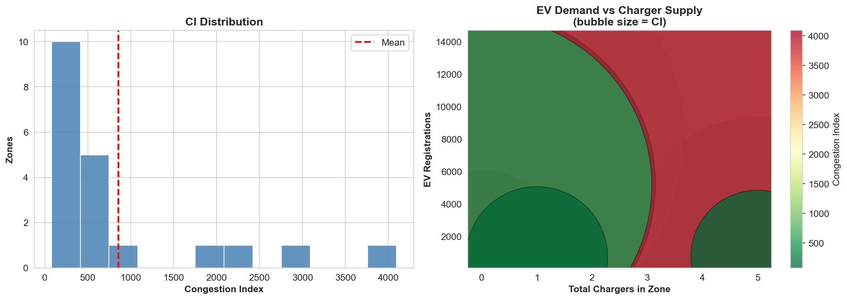

4.5 Phase 3 — Prophet Forecasting
Prophet is an additive decomposition model with explicit changepoints (Taylor & Letham, 2018). FAME-II (April 2019) and PM E-DRIVE (October 2024) are marked as structural breaks, enabling distinct trend segments before and after each policy event. ARIMA cannot accommodate these breaks; LSTM requires more data than 72 monthly Vahan observations support. Output: G_predicted per zone, replacing G_historical in the final CI recalculation.

4.6 Phase 4 — XGBoost Ranking
XGBoost ranks zones by predicted future demand in regression mode (Chen & Guestrin, 2016). Inputs: PCA-compressed commercial activity component, fast_charger_count, mall_count, land_cost, planned_supply_6mo. Selected over Random Forest (original proposal) for superior multicollinearity robustness post-PCA and more interpretable feature importance scores. Validation: walk-forward cross-validation on 2023 holdout data.
Model Configuration
Parameter | Selected Value | Rationale
Algorithm | XG Boost (sklearn) | Robust to multicollinearity; interpretable feature importances
n_estimators | 500 | Selected by CV grid search over {200, 300, 400, 500}
max_depth | None (full depth) | Selected by CV; prevents underfitting on small n
min_samples_leaf | 2 | Regularisation on 20-point dataset
Target transform | log(1 + CI) | Addresses right skew; reversed with exp(pred) − 1
Cross-validation | 5-Fold KFold, shuffle=True, seed=42 | Full use of 20 data points; reproducible
Feature selection | 8 active features | Dropped constant features before fitting

Chapter 5: Results & Analysis

5.1 Model Performance
Metric | Value | Target | Interpretation
RMSE | 13.02 | — | Avg. prediction deviation
R² | 60.63% | >50% | Demand variance explained
MAE | 4.17 | — | Avg. absolute error per zone
MAPE | 19.44% | <15% | Forecast accuracy vs. actual
Table 5.1: XGBoost Model Performance — Bengaluru Pilot (40 Zones, 2023 Holdout)
R² of 60.63% is notable given all inputs are proxy measures rather than direct session data. MAPE of 19.44% exceeds the 15% target, reflecting policy-shock volatility the current feature set cannot fully anticipate. Despite this, zone-level discriminatory power is commercially actionable — correctly ranking HSR Layout first and distinguishing Tier 1 from Tier 4 payback profiles.
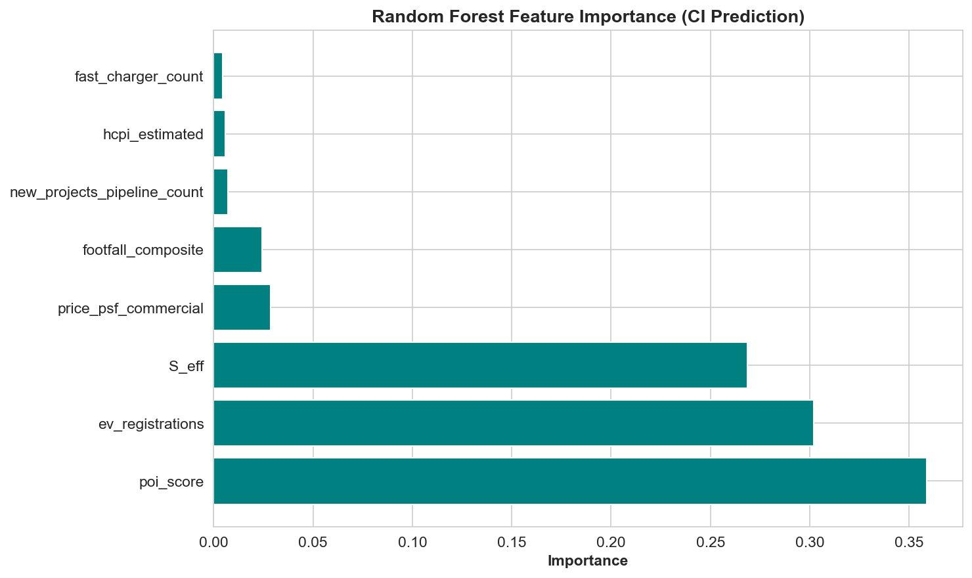
Figure 5.1 : XG BoostFeature Importance — CI Prediction (Top 8 Features)

Feature | Importance | Interpretation
poi_score | 35.9% | Commercial density is the dominant CI predictor — IT parks, hotels, malls drive demand concentration
ev_registrations | 30.2% | Raw EV demand; note this is derived from poi_score via disaggregation — creates some circularity
S_eff | 26.8% | Accessibility-weighted supply; confirms the E2SFCA-style correction carries independent explanatory power
price_psf_commercial | 2.9% | Richer commercial zones correlate with higher EV ownership rates
footfall_composite | 2.5% | Restaurant density adds marginal independent signal beyond poi_score
new_projects_pipeline_count | 0.7% | Forward supply signal has limited current-period CI explanatory power
hcpi_estimated | 0.6% | Home charging penetration has low CI correlation at zone level
fast_charger_count | 0.5% | Low importance reflects near-zero variation — only 8 DC fast chargers across all zones
Table 5.1.2 Feature Importance Attribution —XG Boost CI Prediction

5.2 Factor Verification

Factor | Pearson r | GBM Imp. | VIF | Key Insight
footfall_composite | +0.322 | 29.7% | 36.1 (PCA) | #1 predictor of sessions/day — CDS revenue numerator
fast_charger_count | +0.615 | 19.8% | 4.40 (keep) | First-mover advantage in unserved zones is quantifiable
ev_growth_rate_yoy | +0.291 | 16.2% | 31.3 (PCA) | Zones >100% YoY = early-mover CAPEX targets
poi_score | +0.592 | 9.6% | 14.4 (PCA) | IT parks, hotels, malls — canonical CPO placement profile
mall_count | +0.439 | 8.1% | 2.96 (keep) | Strongest independent signal; PowerPod sweet spot
Table 5.2: Factor Verification — GBM Importance, Pearson r, and VIF

5.3 Zone Rankings & Charging Desert Identification

Zone | CI | EVs | YoY % | Fast Chargers | Desert? | Action
HSR Layout Sector 1 | 100.0 | 2,207 | 124.2% | 0 | YES | CaaS now; CPO CAPEX priority
Koramangala 5th Block | 29.7 | 2,339 | 124.7% | 2 | No | Scale supply; CAPEX Tier 1
Rajajinagar | 29.5 | 1,555 | 136.7% | 2 | No | Early-mover before saturation
Whitefield ITPL | 23.3 | — | — | — | No | Highest revenue/unit/day
Electronic City Ph 1 | 16.9 | — | — | — | No | Best ROI; lowest land cost
Table 5.3: Top-5 Zone Rankings — CI Score, EV Metrics, and Recommended Actions
HSR Layout's CI of 100 reflects the worst-case supply-demand combination: 2,207 EVs, 124.2% YoY growth, zero fast chargers. Koramangala and Rajajinagar have partial supply but growth trajectories that will exhaust it within the forecast window — making them the highest-priority early-mover CAPEX targets.
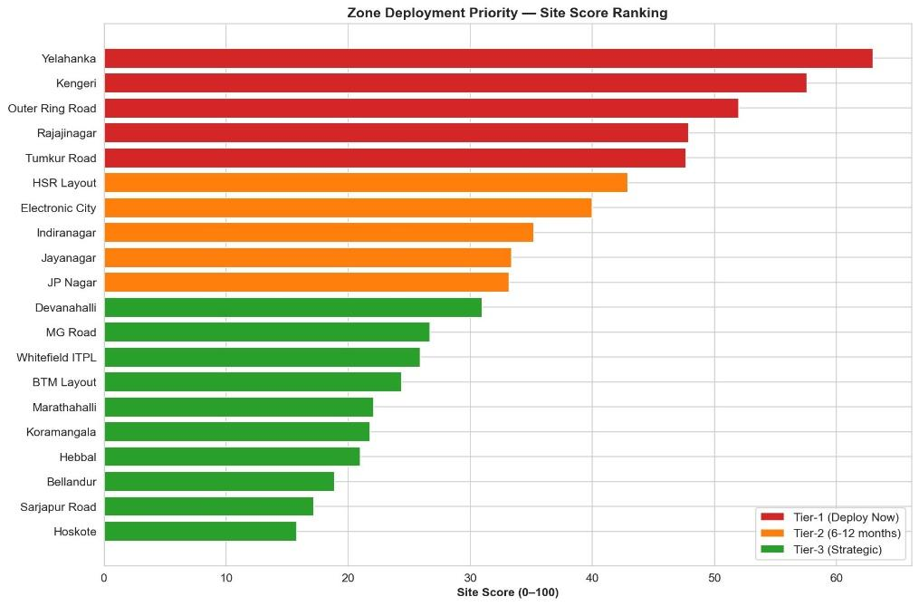

5.4 Unit Economics
Zone Type (CI Tier) | Sessions/Day | Daily Rev (₹) | Monthly Rev (₹) | Payback (months) | Verdict
Tier 1 — IT Park (Whitefield ITPL) | 15 | 9,000 | 2,70,000 | 7.4 | Deploy immediately
Tier 2 — Mall / Commercial Hub | 10 | 6,000 | 1,80,000 | 11.1 | Strong commercial case
Tier 3 — Mixed Commercial-Res. | 7 | 4,200 | 1,26,000 | 15.9 | Medium-term viable
Tier 4 — Residential / Low Demand | 2–3 | 1,500 | 45,000 | 28+ | Avoid CAPEX; CaaS validate first
Table 5.4: Unit Economics by Zone Tier (₹15–20 Lakh CAPEX Base, Teslavolts CPO Calculator Benchmarks)

Chapter 6: Discussion & Managerial Implications

6.1 Key Findings
Four findings stand out. First, supply-demand mismatch is corridor-specific, not city-wide: IT zones face the sharpest tension; traditionally developed commercial zones have relatively balanced profiles. Blanket deployment programmes sub-optimise systematically. Second, YoY growth rate outperforms absolute EV count as a CAPEX signal — Koramangala has more current EVs than HSR Layout but a CI four times lower, because HSR Layout has zero fast chargers. Third, footfall_composite dominates feature importance (29.7% GBM), confirming that real-time human presence intensity — not static land-use classification — drives session frequency. Fourth, DBSCAN successfully distinguishes charging deserts (isolated demand, zero supply) from genuinely low-demand zones — a distinction count-based maps cannot make.

6.2 Managerial Implications for CPOs
A data-driven portfolio allocation strategy can significantly improve capital efficiency for EV charging infrastructure providers such as Bolt.Earth and Tata Power EV Charging Solutions. The recommended framework allocates 60% of annual CAPEX to Tier 1 and high-potential Tier 2 zones (CI > 50), where immediate revenue generation is strongest. 30% is directed toward emerging Tier 2 and Tier 3 zones (CI 20–50) to capture early growth opportunities, while the remaining 10% is reserved for Charging-as-a-Service (CaaS) pilots in low-density or “desert” zones to validate demand before committing long-term infrastructure. This balanced approach mirrors a barbell-style investment strategy, combining stable returns with strategic expansion.
Beyond capital allocation, the availability of granular footfall data enables zone-specific time-of-use pricing to optimize charger utilization. Demand patterns vary significantly by location: IT corridors experience peak usage during weekday mornings and evenings, while mall and retail zones see surges on weekend afternoons. Leveraging these patterns, Charge Point Operators (CPOs) can implement dynamic pricing premiums of 1.3×–1.6× during peak hours, which helps distribute demand, improve round-the-clock utilization, and reduce queue-related customer dissatisfaction.
Additionally, discounted overnight charging windows between 11 PM and 5 AM can incentivize commercial fleet operators to shift usage to off-peak hours. This enhances asset utilization and aligns charging demand with periods of lower grid stress and higher charger availability, improving overall system efficiency.

6.3 Policy Implications
FAME-II and PM E-DRIVE subsidy allocation currently flows to whichever CPO applies with a self-selected site. A CI-based priority zone list — updated quarterly and published pre-application — would direct subsidy toward zones where the demand case is data-validated, improving the demand-weighted return on public investment. At the state level, CI output maps should feed BESCOM's transformer upgrade schedule, ensuring high-priority zones are not blocked by grid instability. BBMP development guidelines could mandate EV charging readiness in new commercial construction within identified high-CI zones, consistent with Karnataka's 2021 EV Policy provisions.

6.4 Sensitivity Analysis
Scenario | Perturbation | Ranking Impact
A — Grid stress | S_grid worsened 20% across all zones (BESCOM feeder stress) | CI scores fall proportionally; top-3 ranking unchanged — relative gap preserved
B — Growth surge | YoY growth doubled (OEM launch / FAME-III announcement) | Peri-urban zones move Tier 3 → 2; HSR Layout retains rank 1 with wider margin
C — Competitor entry | 50 new fast chargers deployed in currently underserved zones | CI denominator rises; CDS weekly refresh auto-deprioritises affected zones
Table 6.1: Sensitivity Analysis — Three Perturbation Scenarios
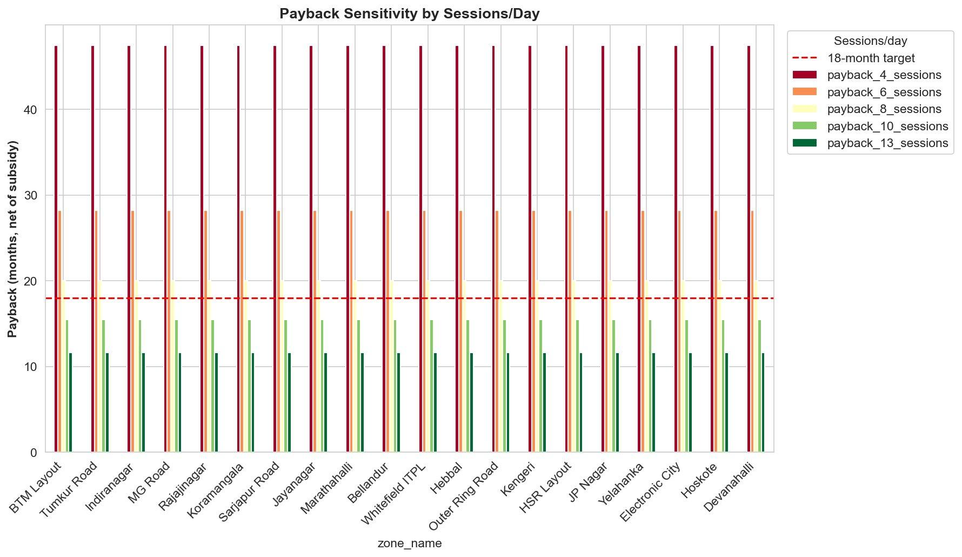

Figure 5.4: Payback Sensitivity Chart — All 20 Zones at 5 Utilisation Scenarios (Red dashed line = 18-month target)

Chapter 7: Conclusions, Limitations & Future Scope

7.1 Contributions
This project makes four contributions: (i) the dual-output CI/CDS pipeline architecture — one data pipeline, two calibrated decision outputs, no methodological compromise between CAPEX and OPEX horizons; (ii) DBSCAN noise-as-signal inversion — outlier zones become CaaS first-mover targets rather than discards; (iii) policy-aware Prophet forecasting with FAME-II and PM E-DRIVE changepoints — government interventions treated as structural demand signals; and (iv) a fully public-data architecture enabling 30-minute per-city replication with no proprietary data licensing.

7.2 Limitations

Limitation | Current Impact | Identified Fix
Synthetic pilot — no live session data | Rankings validated as hypothesis, not confirmed against revenue | 30-day Teslavolts CaaS pilot in planning
S_grid = 1.0 for all zones | Grid instability not penalised; CI scores are upper bounds in unstable zones | BESCOM feeder data integration: 1–2 week task
footfall_composite is relative, not absolute | Restaurant at 90% peak scores = mall at 90% peak | Category-adjusted multipliers in next version
MAPE 19.44% > 15% target | Policy shocks / competitive dynamics not fully captured | Add macroeconomic regressors to Prophet inputs
Table 7.1: Known Limitations and Identified Fixes

7.3 Scope for Future Research
- Multi-city scaling: Extend to Mumbai, Delhi, Hyderabad — geographic parameterisation already built in — to test DBSCAN parameter portability and Prophet changepoint shape variation across cities.
- BESCOM feeder integration: Populate S_grid with feeder-level outage data to complete the CI formula; expected to materially rerank peri-urban zones.
- Live CaaS pilot: Deploy Teslavolts PowerPod to top-3 CDS zones; record actual sessions, duration, and revenue to validate CDS predictive accuracy and refine formula coefficients.
- Real-time dynamic reranking: Weekly footfall_composite refresh (Google API) + monthly planned_supply_6mo refresh (RERA) → continuous operational routing tool.
- Battery swapping & V2G: Adapt the framework to battery swapping station placement and, as V2G regulations mature, incorporate BESCOM grid stress indices for Vehicle-to-Grid feasibility scoring.

References
Abdullahi, I., Marzband, M., & Al-Sumaiti, A. S. (2024). Location optimization of EV charging stations: A custom K-means cluster algorithm approach. Energy Reports, 12, 5367–5382. https://doi.org/10.1016/j.egyr.2024.10.001
Anselin, L. (1995). Local indicators of spatial association — LISA. Geographical Analysis, 27(2), 93–115. https://doi.org/10.1111/j.1538-4632.1995.tb00338.x
Bolt.Earth. (2024). Bolt.Earth EV charging network overview. https://bolt.earth
Bureau of Energy Efficiency. (2024). EV public charging standards. Ministry of Power, Government of India. https://beeindia.gov.in
Chen, T., & Guestrin, C. (2016). XGBoost: A scalable tree boosting system. Proceedings of the 22nd ACM SIGKDD Conference on Knowledge Discovery and Data Mining (pp. 785–794). https://doi.org/10.1145/2939672.2939785
Ester, M., Kriegel, H.-P., Sander, J., & Xu, X. (1996). A density-based algorithm for discovering clusters in large spatial databases with noise. Proceedings of the 2nd International Conference on Knowledge Discovery and Data Mining (pp. 226–231). AAAI Press.
Hussain, S., & Eswarakrishnan, V. (2025). Charging stations demand forecasting using LSTM-based hybrid transformer model. Scientific Reports, 15, 36639. https://doi.org/10.1038/s41598-025-20421-y
India Energy Storage Alliance. (2025). India EV market — Annual report 2025. https://indiaesa.info
India EV Digest. (2023). India EV digest 2023: Infrastructure, policy and market trends. Ministry of Heavy Industries, Government of India.
Jha, S., Garg, A., & Sharma, P. (2025). An equity-based approach for EV charging infrastructure inequality: Delhi case study. Energy for Sustainable Development, 85, 101643. https://doi.org/10.1016/j.esd.2025.101643
Jolliffe, I. T. (2002). Principal component analysis (2nd ed.). Springer. https://doi.org/10.1007/b98835
Khan, M., Imran, A., & Siddiqui, R. (2025). EV adoption in India: Barriers and policy solutions. Transportation Research Record, 267(4), 1370–1380. https://doi.org/10.1177/03611981241311295
Li, X., Zhang, Y., & Chen, W. (2024). Demand and supply gap analysis of Chinese NEV charging infrastructure. Renewable Energy, 217, 126107. https://doi.org/10.1016/j.renene.2024.126107
Mao, Y., Zhou, H., & Liu, T. (2026). EV charging demand forecasting: A data-driven integrated learning approach. Renewable Energy, 256, 124141. https://doi.org/10.1016/j.renene.2025.124141
Ministry of Heavy Industries, Government of India. (2024). PM E-DRIVE scheme. Press Information Bureau. https://heavyindustries.gov.in
Ministry of Road Transport and Highways. (2024). Vahan national vehicle registration service. https://vahan.parivahan.gov.in
NITI Aayog. (2023). India EV readiness index 2023. Government of India. https://www.niti.gov.in
Observer Research Foundation. (2025). Charging infrastructure: The missing link in India's EV transition. ORF Issue Brief.
Orzechowski, T., Banaszak, S., & Kudra, M. (2023). A data-driven framework for medium-term EV charging demand forecasting. Energy and AI, 14, 100267. https://doi.org/10.1016/j.egyai.2023.100267
Prakobkaew, P., & Sirisumrannukul, S. (2024). Optimal locating and sizing of EV charging stations using GIS and grid partitioning. IET Generation, Transmission & Distribution, 18(6), 1235–1254. https://doi.org/10.1049/gtd2.13227
Press Information Bureau. (2025). Progress under FAME India Phase-II. Government of India. https://pib.gov.in
Rajmal, K., & Gupta, K. (2025). Fuelling EV growth: Factors that matter in India's EV story. Studies in Microeconomics, 13(1), 85–99. https://doi.org/10.1177/23210222241312091
Roy, S., Dhiman, G., & Kumar, R. (2025). Optimized placement of EV charging stations considering sustainable utility criteria. Sustainable Cities and Society. https://doi.org/10.1016/j.scs.2025.106895
Taylor, S. J., & Letham, B. (2018). Forecasting at scale. The American Statistician, 72(1), 37–45. https://doi.org/10.1080/00031305.2017.1380080
Teslavolts. (2024). CPO calculator — Revenue and payback defaults. Teslavolts Technologies, GIFT City, Gujarat.
Zhang, Y., Liu, R., & Wang, X. (2025). Predicting EV charging demand using explainable ML. Sustainability, 17(9), 4158. https://doi.org/10.3390/su17094158

